Assessment type (þ):
☐ Questioning (Oral/Written)
☐ Practical Demonstration
☐ 3rd Party Report
☒ Other – Lab

Assessment Resources:
The base requirements this assessment task include:
- IDE or editor for developing Python programs (only IDLE and PyCharm supported by the college)
- Access to Office 365 & Microsoft Word
- Virtual machine
You may not need all these for every part in this assessment

Assessment Due:
This assessment is due after the weekly session, Week 3, Friday 17:00.

Assessment Instructions:
- Your code must be written in IDLE or PyCharm IDEs. If you are using a different IDEs or a different structure for your application, then assistance from your lecturers may be limited (at best).
Discuss with your lecturer before straying too far off the path!
- All resources used should be referenced with the question. Answers may not be copied and pasted from any resource. All answers must be reworded to display your understanding.
- You may only use Python functionality, methods and libraries which were taught in this unit.
- First line of code in a program should have the student’s name and number, as proof of authenticity.
- Screenshots of all programs must be included in this document, with the appropriate question.
- Screenshots of testing, showing your code works as intended, should be included with the relevant question.
- Python programs should be named: XXX_Lab##_SYY_QZZ
Replace XXX with your initials
Replace ## with Lab number
Replace YY with Section number,
Replace ZZ with Question number
- It is a submission requirement that all screen shots be signed in some way. Some acceptable examples of signed screen shots are shown below.
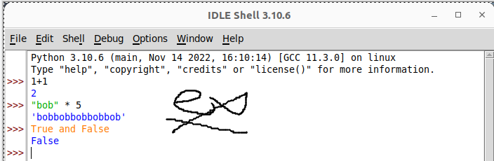
Example 1: Signed using a simple drawing tool.
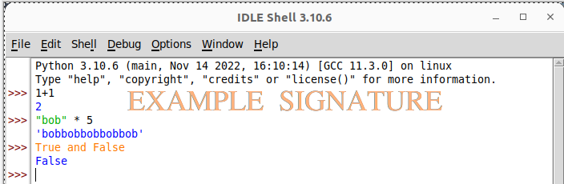
Example 2: Water marked signature.
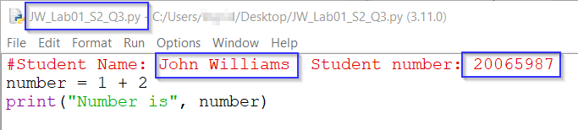
Example 3: Program named as prescribed, as well as first line comment with student name and number. Program saved as pre-described.
- All python programs must be included in the submission, as well as this document.

Assessment Instrument:

Section 1: Boolean expression
Booleans are either true or false, they are commonly used to in iteration and evaluation-based syntax. Run the following exercises in the Python shell/interpreter.
- Run the following operations and
- evaluate the output:
Code | Screenshot and evaluation
True | 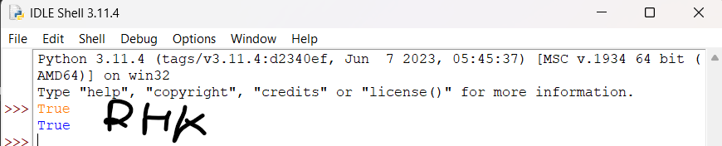
False | 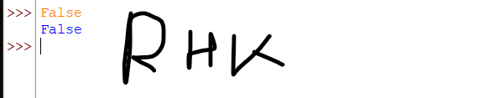
5 == 5 | 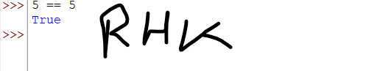
3 > 5 | 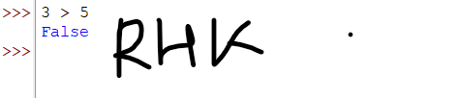
5 != 5 | 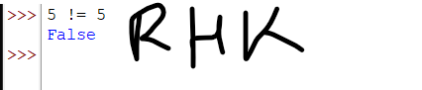
aBool = True  type(aBool) | 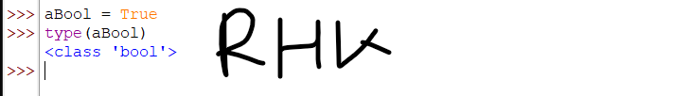
5 is 7 | 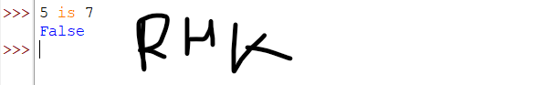
7 is 7 | 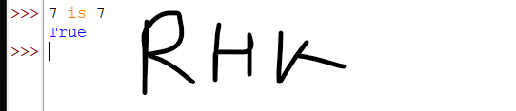
7 is not 5 | 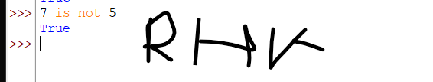
8/4 is not 2 | 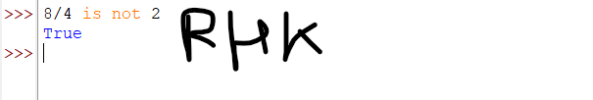
8//4 is 2 | 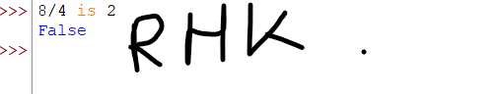
- What is the difference between the / and the // operators?
/ (Classic Division Operator): Regardless of whether the operands are floats or integers, this operator always returns a floating-point number after performing standard division.
// (Floor Division Operator): This operator rounds the result to the closest whole number (integer) after performing division.
- What does the modulus operator do?
The modulus operator in Python is an arithmetic operator that yields the remainder of a division operation and is denoted by the percent sign (%).
- Why does 10 == 2 + 2*4 in Python return the answer True and not False?
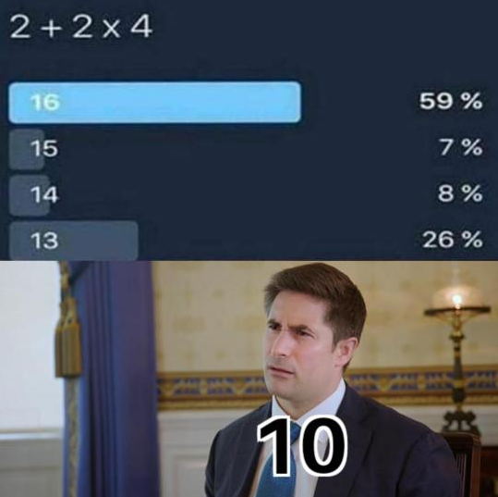
This is because of the operator precedence. So * has higher precedence than +, therefore at 2 * 4 = 8 and then 2 added to 8, which results in 10 and 10 == 10 is True

Section 2: Conditional execution
Understanding a conditional execution is key to decision making in coding. Run the following code in the Python shell/interpreter.
- Run the following operations and evaluate the output:
Remember, watch for your indenting here!
Code | Screen shot
if True:  print("True is true") | 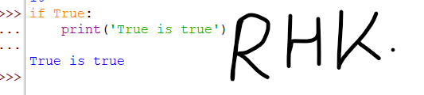
if False:  print("True is true")  else:  print("False") | 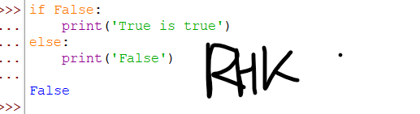
if 1==1 and 2==2:  print(“Match!”) | 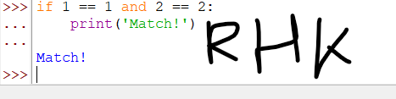
if 1==1 or 2==10:  print(“Matched with OR!”) | 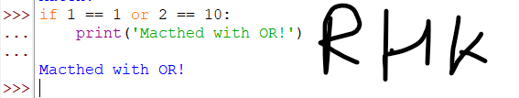
- Run the following code in a code file to demonstrate a chained conditional execution statement:
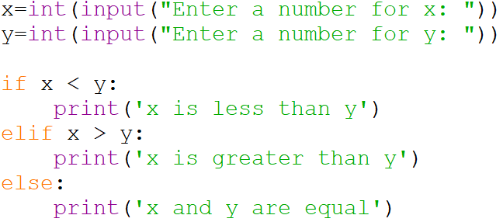
Input | Screenshot of output
Enter a number for x: 5  Enter a number for y: 7 | 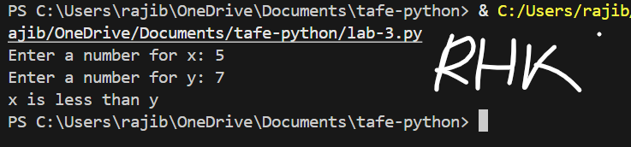
Enter a number for x: 7  Enter a number for y: 5 | 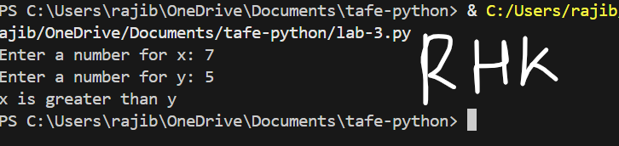
Enter a number for x: 5  Enter a number for y: 5 | 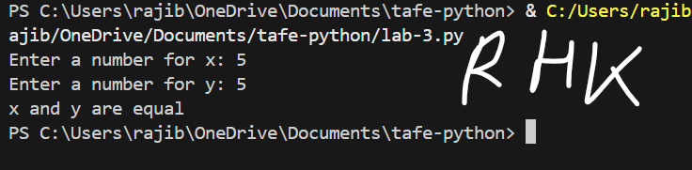
Enter a number for x: a  Enter a number for y: 5  Your program will crash | 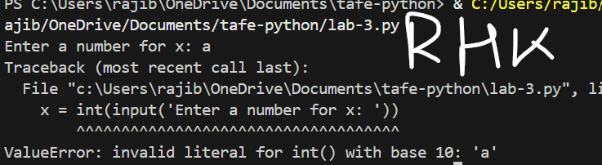
Explain why the program crashed when x is a, and y is 5 were entered. | Because a cannot be converted to a number

Section 3: Try and except
Try and except are another form of conditional checking (based on syntax errors). It’s important to understand exceptions and how they are handled. You may find some of the online documentation to be useful for this topic.
Using code files, complete the following tasks.
- What is meant by (and what could possibly cause) the following exceptions?
Exception |  | Description and cause
TypeError |  | When an operation or function is applied to an object of an improper or incompatible data type, a built-in exception known as TypeError is raised.
NameError |  | When a program tries to use a name (variable, function, class, module, etc.) that has not been defined or is not accessible in the current scope, it generates a NameError
ValueError |  | When an argument with the right data type but an incorrect value is passed to a function or operation, a built-in exception known as a ValueError is raised.
IndentationError |  | In Python, an IndentationError is a built-in exception that arises when code is not properly or consistently indented.
- Examine the code in the screen shot. Improve this code by using a try and except statement to handle any incorrect user input gracefully (remember to demonstrate that it works): 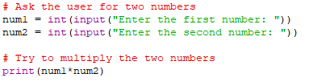
Input | Screenshot of output
Enter the first number: a  Enter the second number: 7 | 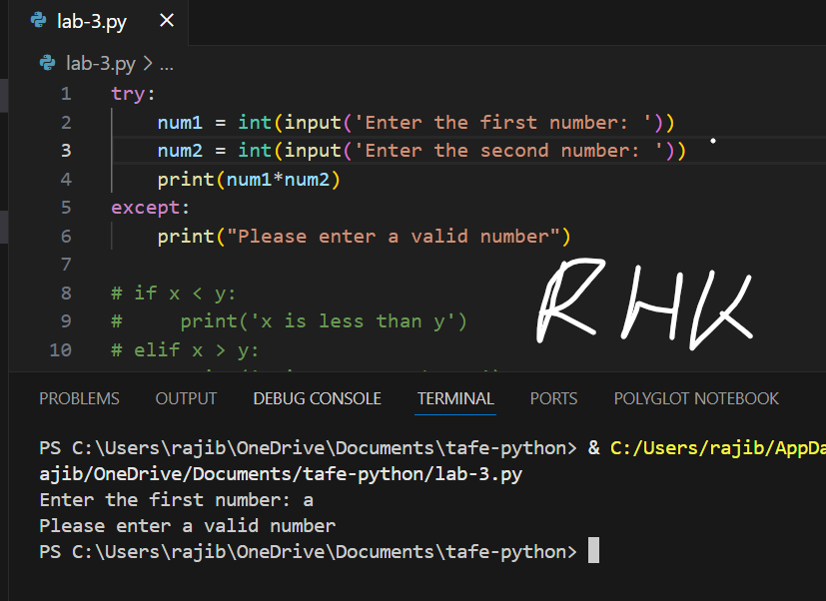
Enter the first number: 7  Enter the second number: b | 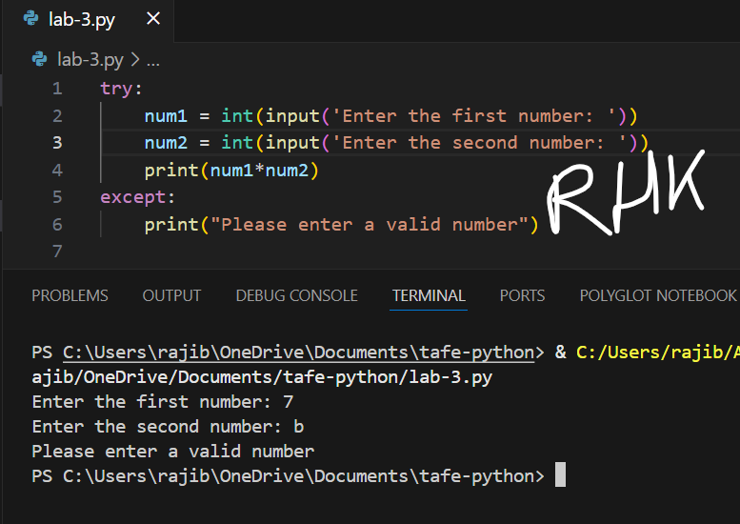
Enter the first number: 2  Enter the second number: 7 | 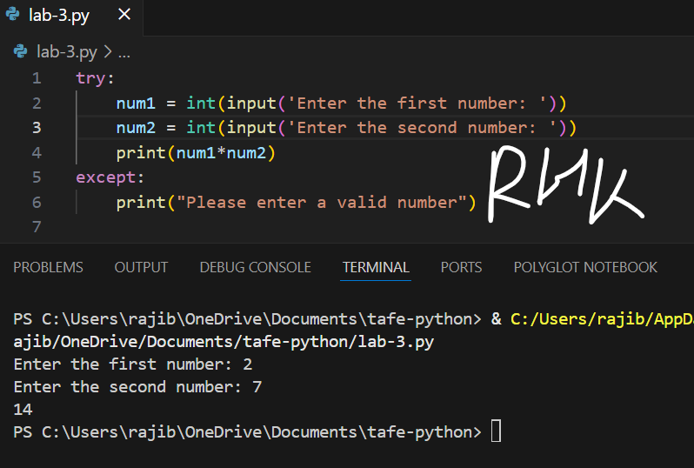
- Write the following code and execute it, it’s a good example how a failure can be handled.
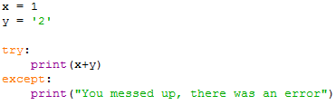

Run the code. This code should fail because you are trying to perform a mathematical operation on a string and integer. The script does not crash because try and except are used to handle any errors. This won’t tell you why there was an error, only that there was one.
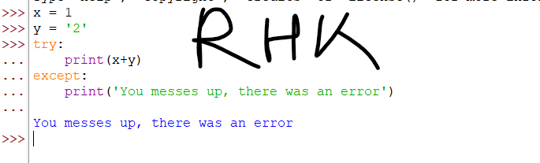
- Modify your code to capture the error message and print it out by replacing:
with:
Run the script. What is the error message presented on screen?
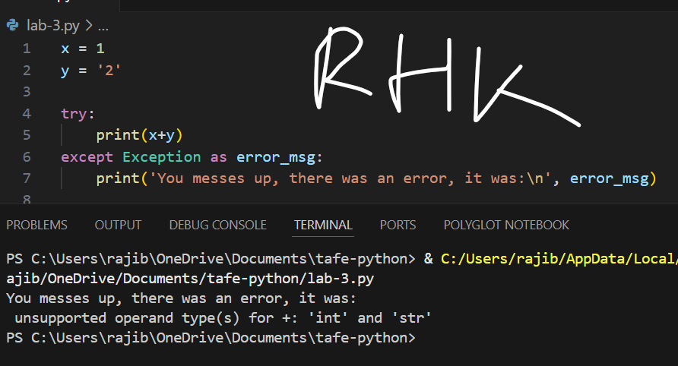

Section 4: Debugging

How it works:
It can get complicated when several things are happening inside of a script. You may need to use the debugger to assist you in working out what is happening in your script.
- Open the debugger
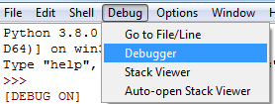
- In the debugger, make sure the Stack and Locals boxes are ticked (the two other boxes provide you with more information than needed in this course). Leave the debugger open and run your script from the previous section more time.
- The Debugger will run your code one line at a time and tell you each variable as it is seen by the interpreter. There are two buttons to do this:
  - Step: The step button will execute each line of code in your entire script one line at a time (this includes all the lines of code in all the functions you use (including Python’s prebuilt functions like print() and input())).
  - Over: the over button will process the script line by line without going into the code of each individual function. This is more useful when you just want to see what variables are changing without going through all the functions in your code (it’s safe to assume that the Python prebuilt functions are error free).

Eventually the error should appear in yellow. You should be able to quickly identify the issue by looking at the variables (see the screen shot example).

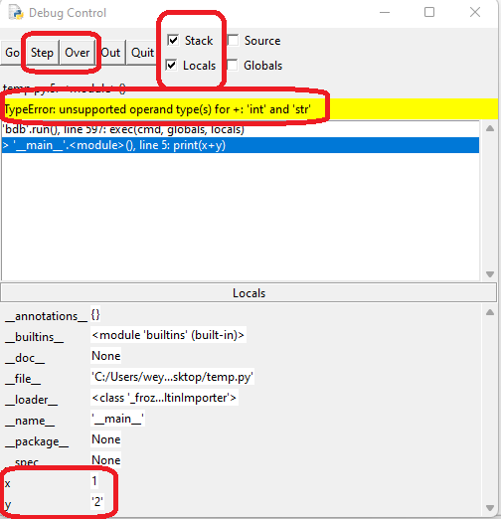

Question
From BlackBoard, download the “Lab 3 debugger” file and open it in Python. This simple program creates a list of people and randomly removes one from it.
Use the debugger and the script (like the previous steps) to identify which family member was removed at random and what the random number was.
Family member that was removed: Roger
Random number was: 4
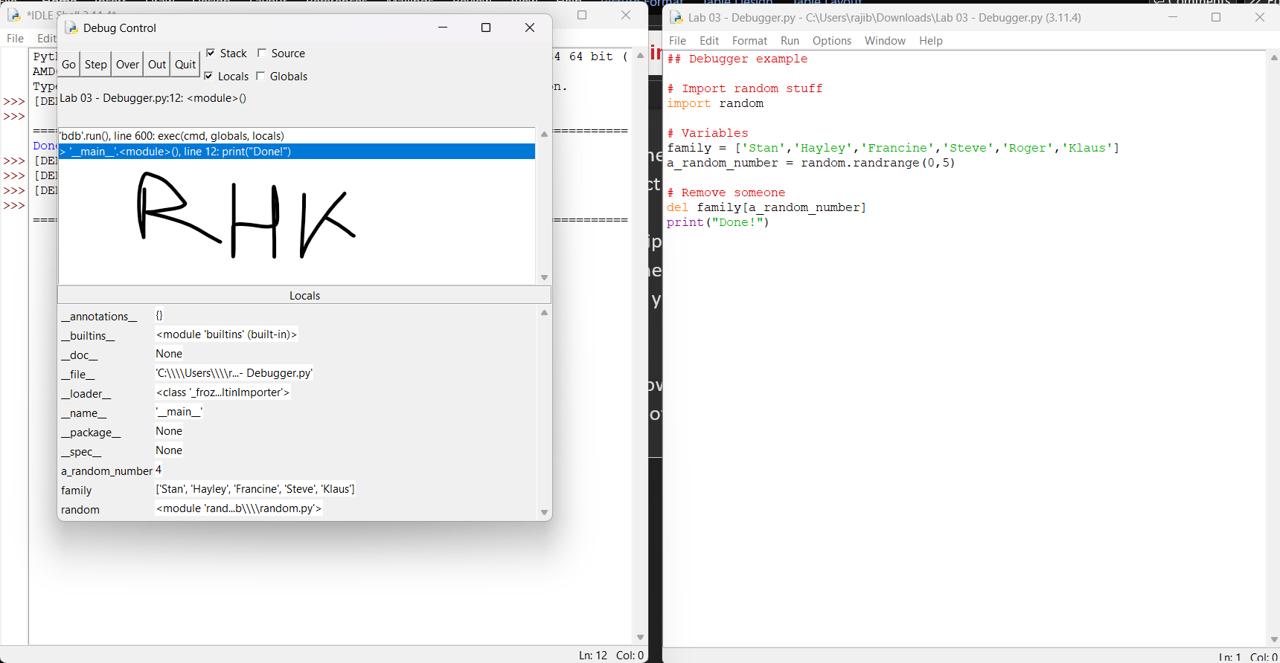

Section 5: A challenge using chained and nested conditionals.
You will often need to use several if statements in a row to determine the action that should be taken based on an input of some description. Combine your skills to complete the following challenge using a code file (use the flow chart in appendix A to help you if required):
- Create a simple input checking script that will ask a user to input a valid integer. The script must:
  - Ensure the number input is an integer between 0 and 31. Be mindful: 0 and 31 are invalid values.
  - Determine if the number is less than 1.
  - Determine if the number is
- smaller than 11,
- 11 to 20 or
- greater than 20
Example screenshots:
- The output must be formatted like the provided screen shots, appropriate messages should also be provided for other scenarios.

- Run the script several times to demonstrate it works as intended.
Note: Uploading your code file is a submission requirement for all code challenges.

Screenshot of output when 11 is entered.
Should display: 11 is between 10 and 20
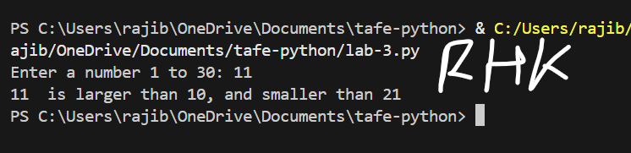

Screenshot of output when four is entered.
Should display: four is not a valid integer
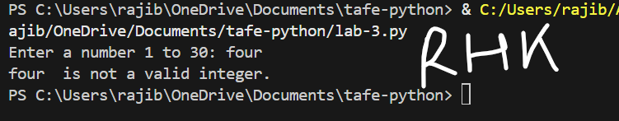
Screenshot of output when 22.1 is entered.
Should display: 22.1 is not a valid integer
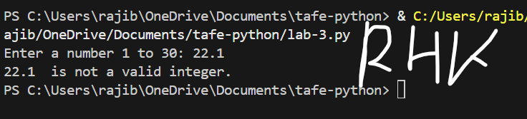
Screenshot of output when 0 is entered.
Your program should give an appropriate error message.
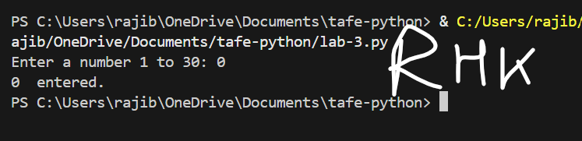
Screenshot of output when 31 is entered.
Your program should give an appropriate error message.
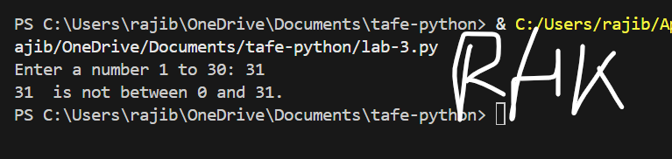
Screenshot of output when 5 is entered.
Your program should give an appropriate message.
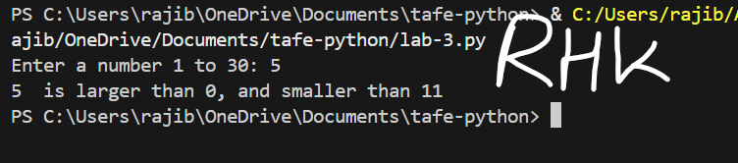

Screenshot of output when 21 is entered.
Your program should give an appropriate message.
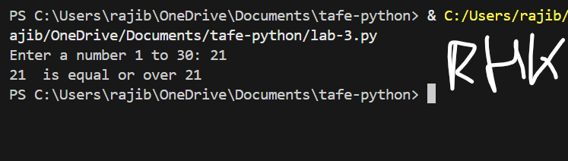
Screenshot of code:
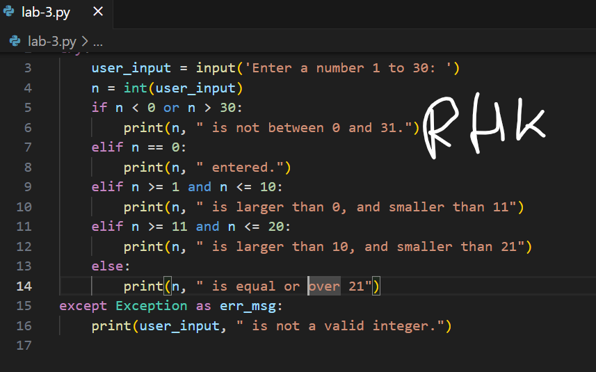

Appendix A – Challenge flow chart

